**School of Electrical and Computer Engineering**

**Third Year B. Tech. (EE)**

**Microcontroller and Applications**

**Course Code: ECE2003B**

**Laboratory Manual**

**2023-2024**

**Preface**

**Microcontroller and Applications**

Microcontrollers are single chip computers, integrating processor, memory and other peripheral modules into a single System-on-Chip (SoC). The single chip solution makes the footprint of the computational element small in the overall system package, eliminating the necessity of additional chips on board. Microcontrollers like 8051, PIC belong to this category. This course includes Silicon Lab​s' 8-bit Microcontroller C8051F340 which implements the standard 8051 organization. It introduces undergraduate students to the field of microcontrollers – what they are, how they work, how they interface with their I/O components, and what considerations the programmer has to observe in hardware-based and embedded programming. Understanding the architecture is the basis followed by hardware intricacies of these processors and their programming will be covered. Different system design examples built around these processors will also be elaborated. The lab for this course covers experiments based on interfacing of peripherals with C8051F340. Programming is in assembly and embedded C. IDE is Keil µvision and Simplicity Studio. After completion of this lab, students should able to develop a microcontroller-based interfaces for real life applications.

**Microcontroller and Applications**

**I N D E X**

|  |  |  |  |  |
| --- | --- | --- | --- | --- |
| **Sr. No.** | **Name of the Experiment** | **Page** | **Date of Checking** | **Signature of Batch I/C** |
| 1 | Simple assembly language programming. |  |  |  |
| 2 | Complex assembly language programming |  |  |  |
| 3 | Interfacing of LED, Buzzer, Relay and Switch with C8051F340 |  |  |  |
| 4 | Interfacing of LCD with C8051F340 |  |  |  |
| 5 | Interfacing of 8-bit DAC with C8051F340 |  |  |  |
| 6 | Programming of on chip ADC |  |  |  |
| 7 | Interfacing DC motor and control its speed using PWM with C8051F340 |  |  |  |
| 8 | Implement UART with C8051F340 |  |  |  |
| 9 | Interfacing Stepper Motor with C8051F340 |  |  |  |
| 10 | Interfacing EEPROM using SPI with C8051F340 |  |  |  |
| 11 | Project Based Learning - Design and implement a microcontroller-based project |  |  |  |

**CERTIFICATE**

Certified that Mr./Ms.__________________________________________ of Class **T. Y. B. Tech.** Division_____ Roll No.____________ has completed the laboratory work in the subject **Microcontroller and Applications** during the **Semester V** in the School of Electrical and Computer Engineering during the Academic Year 2023-2024.

**Signature of the Faculty Head of the School**

**Laboratory Instructions**

**Microcontroller and Applications**

1. Students should have a valid ID card before entering the laboratory.
2. Playing of games on computer in the lab is strictly prohibited.
3. Before leaving the lab, users must close all programs/windows and turn-off the computer.
4. Do not modify or delete any important file and install any software or settings in the computer
5. Internet facility is to be used only for educational/ study purpose.
6. If any problem arises, please bring the same to the notice of Lab In-Charge.
7. Each student must take mobile phones in “Switched Off” or “Vibration” mode while entering and or working in laboratory.
8. In case of theft / destruction of the computers or peripherals, double the cost of that item will be charged from the student/user.
9. Tampering with the hardware or software settings will not be tolerated.
10. Lab Assistants are available to assist with basic computer and software problems.
11. Copying and/or installing of pirated software not permitted.
12. Personal files are not to be stored on the local drive. Students are responsible for their own means of digital storage. All lab computers are configured to remove any data stored or any programs installed by users.
13. Do not leave your personal belongings at the computer desk. The School is not responsible for items left behind.
14. Users are strictly prohibited from downloading, viewing or distributing any offensive materials.
15. Internet surfing or chatting for personal reasons is not allowed.

**Guidelines to use µVISION IDE**

**Keil MicroVision** is an Integrated Development Environment (IDE), which includes a text editor to write programs, a compiler to convert the source code to hex files and a [debugger](http://www.keil.com/mdk5/debug) to test, verify, and optimize the application code.

Keil µVision can be used for:

* Writing programs in C/C++ or Assembly language
* Compiling and Assembling Programs
* Debugging program
* Creating Hex and Axf file
* Testing the program without real Hardware (Simulator Mode)

**Step 1**: After opening Keil uV, Go to **Project** tab and

**Create new µVision project**

Now Select new folder and give name to Project.

**Step 2**: After Creating project now **Select your device model** eg.  Silicon Lab’s C8051F340

**Step 3**: So now your project is created and **Message** window will appear to add start-up file of your device. Click on **Yes** so it will be added to your project folder you are programming in C and click on no if you are programming in assembly.

**Step 4**: Now go to File and create new file and save it with **.asm** extension in the folder where you created the project if you want to write program in assembly language

**Step 5**: Now write your program and save it again.

**Step 6**: After that on left you see project window [if it’s not there….go to View tab and click on restore window to default].

Now come on Project window.

**Right click on target** and click on **options for target**

Here you can change your device also.

**Step 7:** Now Expand target and you will see source group

Right click on group and click on **Add files to source group**

Now add your program file which you have written in C/assembly.

You can see program file added under source group.

**Step 8**: Now Click on **Build target**. You can find it under Project tab or in toolbar. It can also be done by pressing **F7** key.

**Step 9**:  you can see Status of your program in **Build output** window

[If it’s not there go to view and click on Build output window]

Now you are done with your program.

Keil is a tool which can be used as debugger and simulator.

***NOTE:*** *Use this tool for Experiment No. 1 and 2.*

**T. Y. B. Tech (Electrical and Computer Engineering)**

**Trimester: V Subject: Microcontroller and Applications**

**Name: Shreerang Mhatre Class: TY**

**Roll No: 52 Batch: A3**

**Experiment No: 01 and 02**

**Name of the Experiment:**

1. Simple Assembly language programming.

2. Complex Assembly language programming.



**Performed on: 22/08/2023**

**Submitted on: 03/10/2023**



**Aim:**

1. Simple Assembly language programming.

1. Write assembly language program for addition of two 8-bit numbers.
2. Write assembly language program for addition of N 8-bit numbers. Take the input numbers from memory and store result in memory.

2. Complex Assembly language programming.

1. Find square of a number using DPTR.

**Theory:**

Programming in the sense of Microcontrollers (or any computer) means writing a sequence of instructions that are executed by the processor in a particular order to perform a predefined task. The three levels of Programming Languages are as shown in figure 1.1.

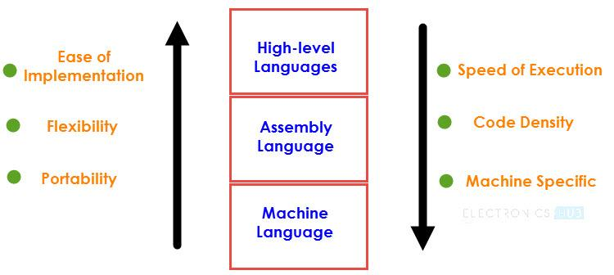

*Figure1.1: Programming Languages*

Assembly Language is a pseudo-English representation of the Machine Language. The 8051 Microcontroller Assembly Language is a combination of English like words called Mnemonics and Hexadecimal codes with the following advantages:

* The Programs written in Assembly gets executed faster and they occupy less memory.
* With the help of Assembly Language, you can directly exploit all the features of a Microcontroller.
* Using Assembly Language, you can have direct and accurate control of all the Microcontroller’s resources like I/O Ports, RAM, SFRs, etc.
* Compared to High-level Languages, Assembly Language has less rules and restrictions.

### Syntax of CIP51 Instruction:

[ Label:]            Instructions                 [;Comments]

|  |
| --- |
| CIP51 has about 109 instructions. These can be grouped into the following categories |
| 1. Arithmetic Instructions 2. Logical Instructions 3. Data Transfer instructions 4. Boolean Variable Instructions 5. Program Branching Instructions |

The ADD instruction is used for the addition of two operands. The destination operand is always in register A, while the source operand can be register, immediate data or memory. The AF, CY and P bits of the flag register are affected by the ADD instruction depending on the operands. Program Status Word (PSW) is the flag register as shown in figure 1.2.

|  |  |  |  |  |  |  |  |
| --- | --- | --- | --- | --- | --- | --- | --- |
| Bit 7 | Bit 6 | Bit 5 | Bit 4 | Bit 3 | Bit 2 | Bit 1 | Bit 0 |
| CY | AC | FO | RS1 | RS0 | OV | UD | P |

*Figure1.2: Bit fields in Program Status Word (PSW) Register*

Table 1.1: Functions of flags

|  |  |
| --- | --- |
| **Symbol** | **Function** |
| **CY** | Carry flag |
| **AC** | Auxiliary Carry flag (For BCD Operations) |
| **F0** | Flag 0 (Available to the user for General Purpose) |
| **RS1, RS0** | Register bank select: RS1 RS0 Working Register Bank and Address 0 0 Bank0  0 1 Bank1  1 0 Bank2  1 1 Bank3 |
| **OV** | Overflow flag |
| **UD** | User definable flag |
| **P** | Parity flag; P=1 for odd no. of 1’s; P=0 for Even no. of 1’s |

**Algorithm:**

**Sample Example:**

**Program:**

***Note:*** *Attach the printout of the code.*

**Conclusion:**

**--------------------------------------------------------------------------------------------------------------------------------------------------------------------------------------------------------------------------------**

**Study Question:**

1. Explain the instructions: DJNZ, INC, SUBB.
2. What is an IDE?

**Additional links:**

1. *https://nptel.ac.in/courses/108105102*
2. [*https://www.electronicshub.org/8051-microcontroller-assembly-language-programming/*](https://www.electronicshub.org/8051-microcontroller-assembly-language-programming/)

**Practical-1**

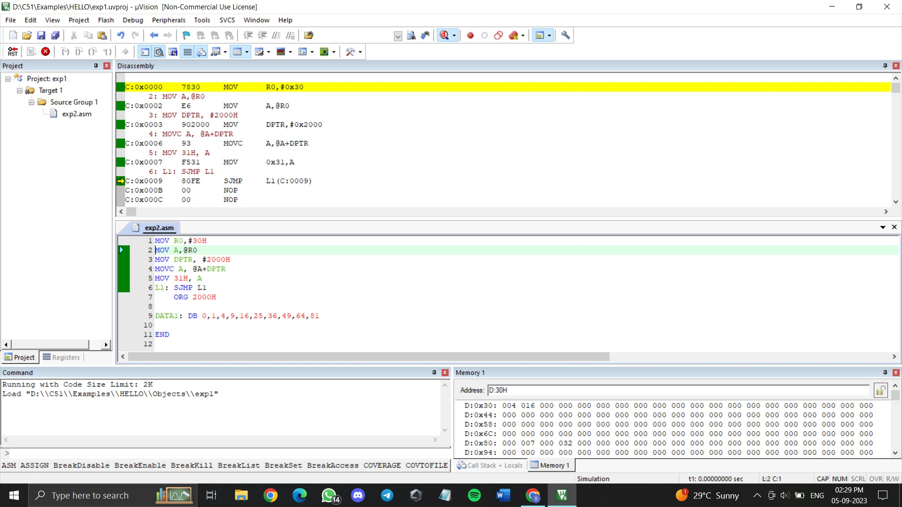

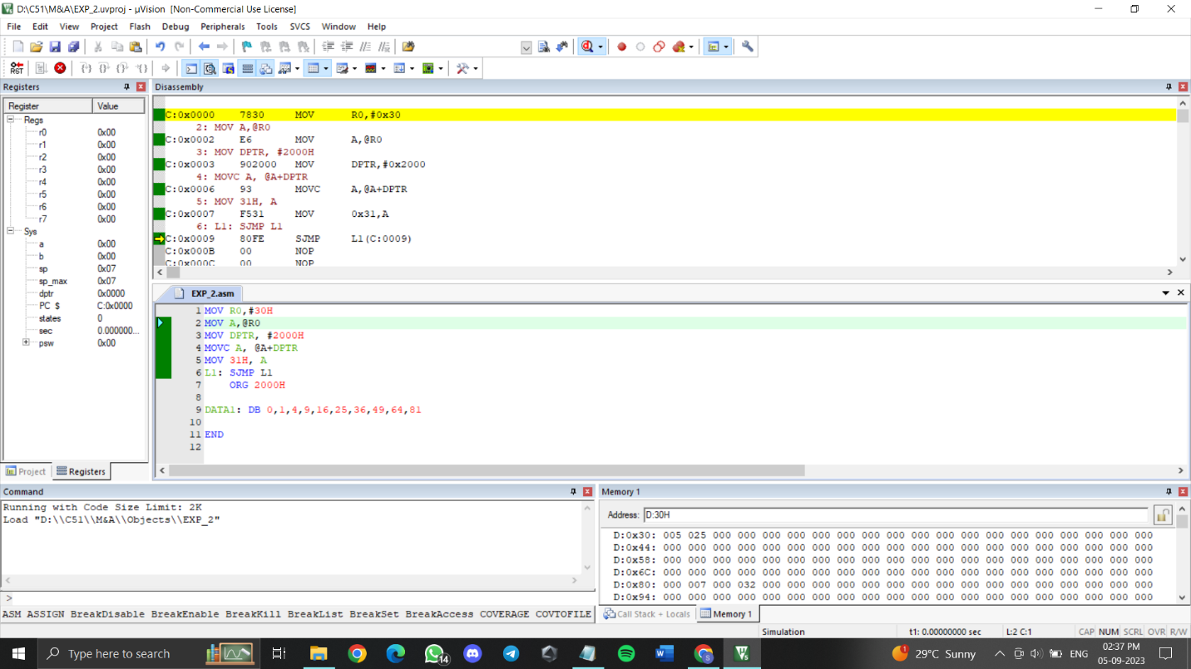

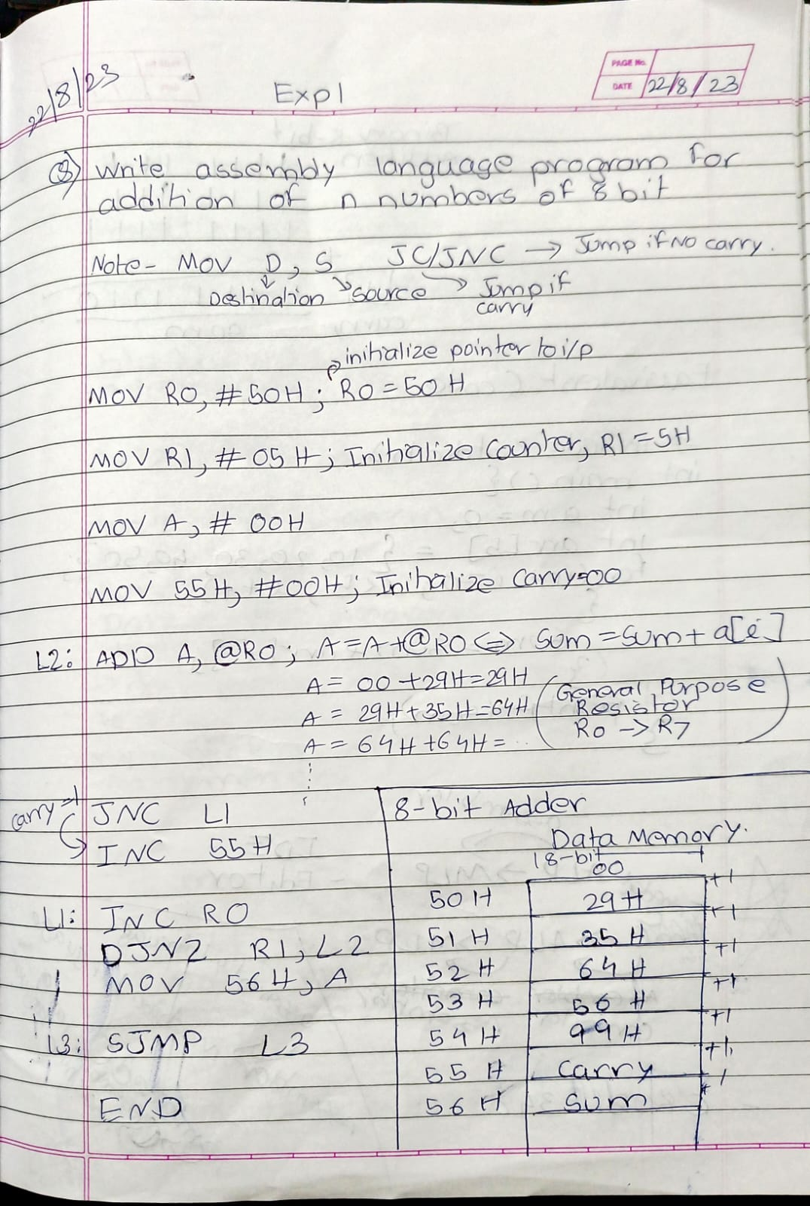

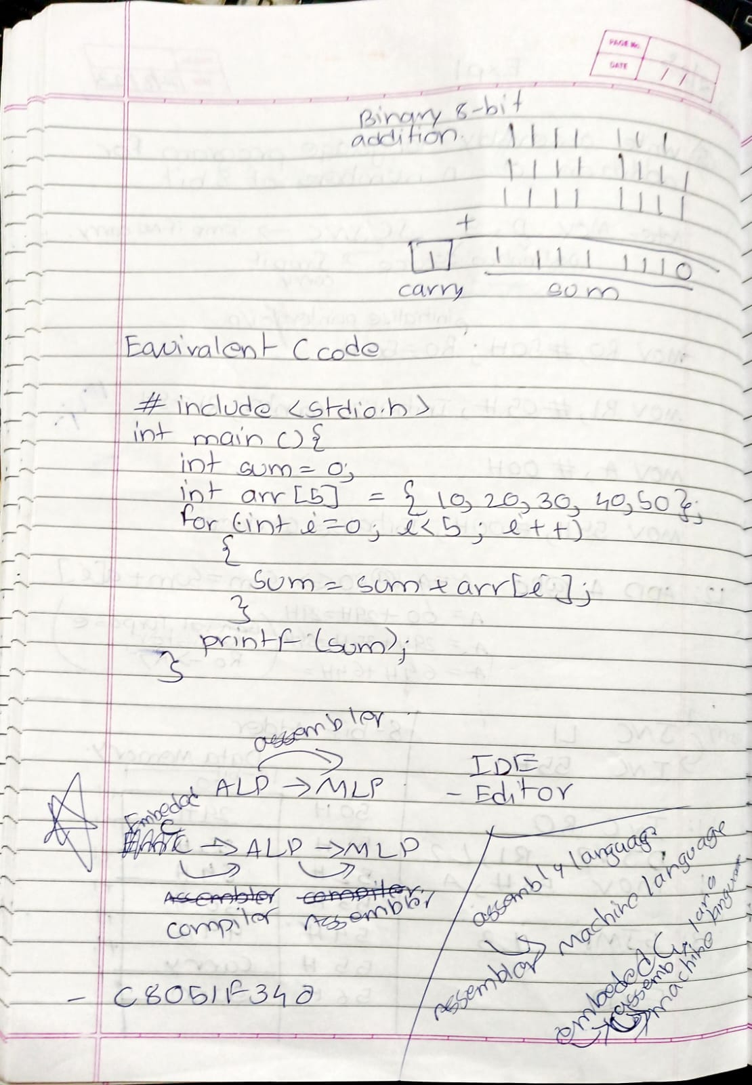

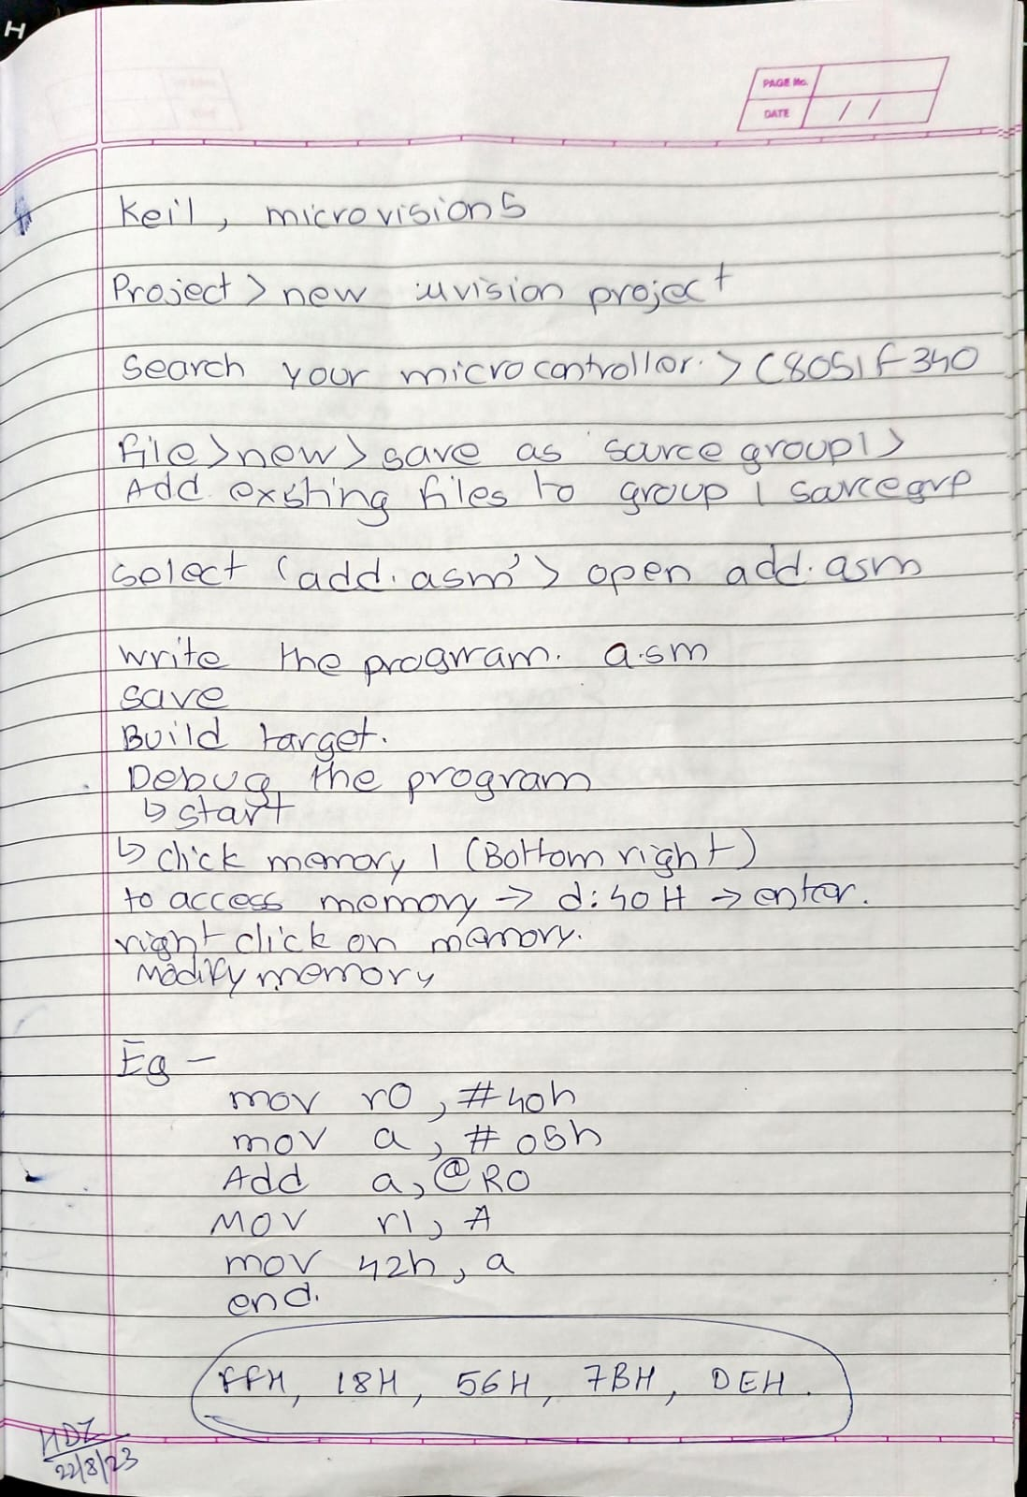

**Practical-2**

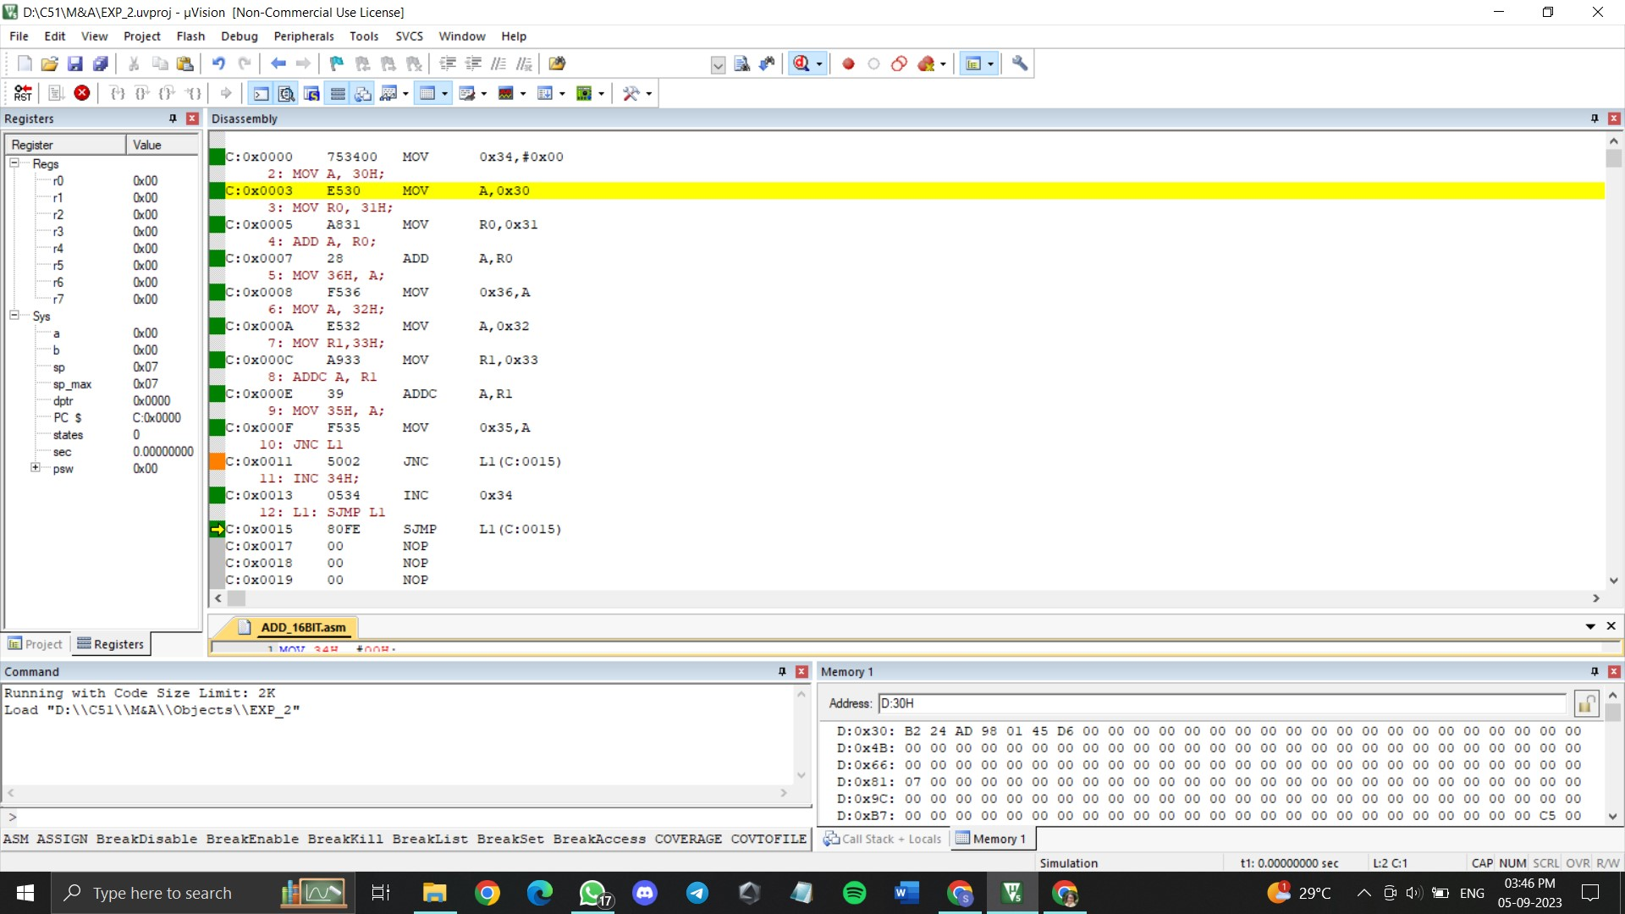

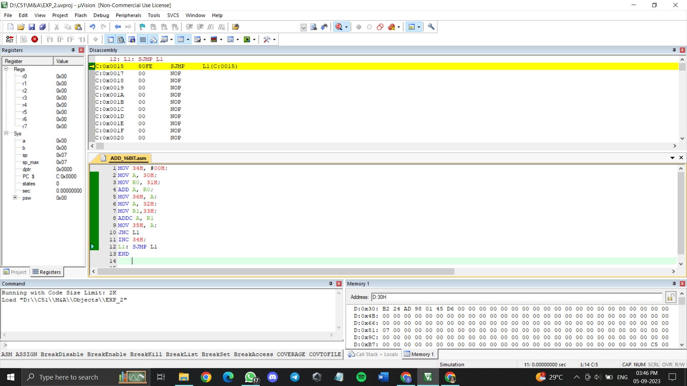

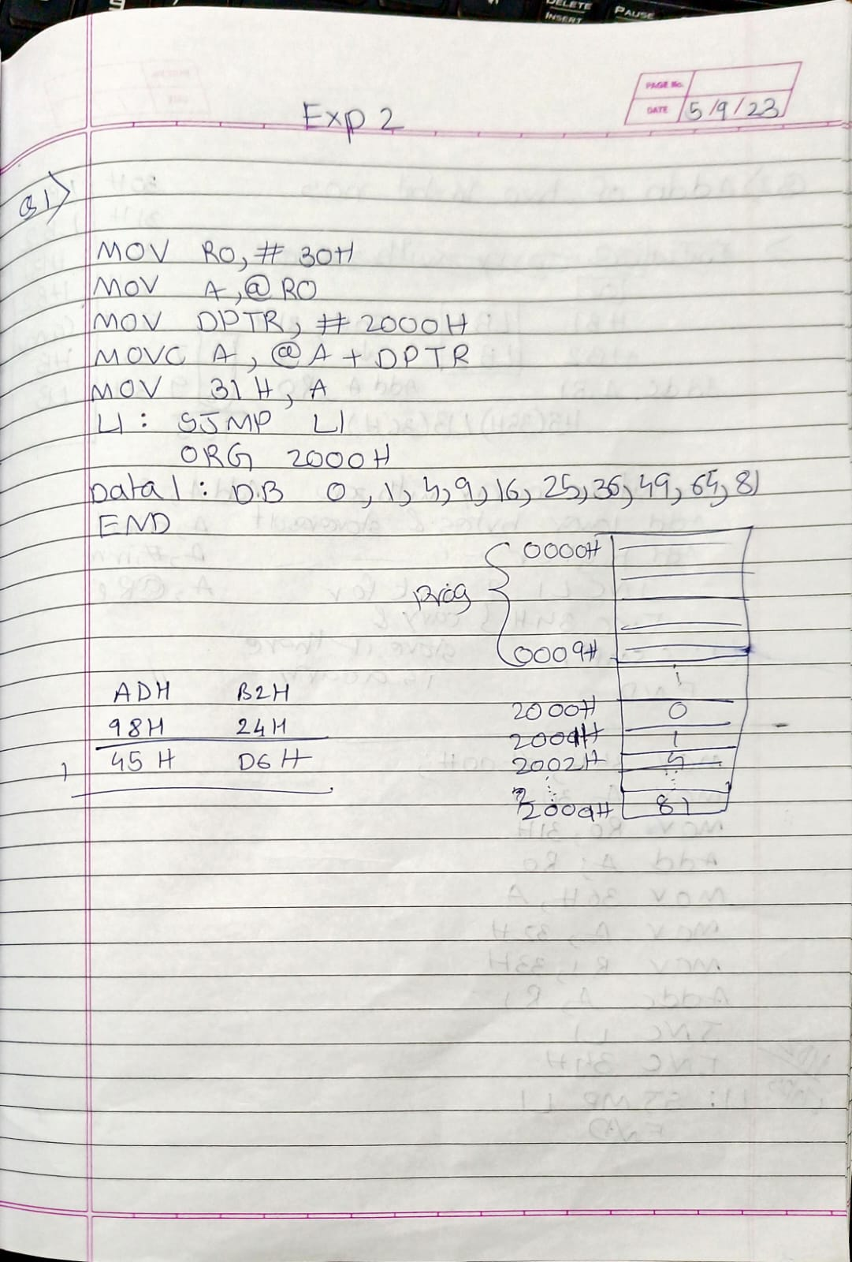

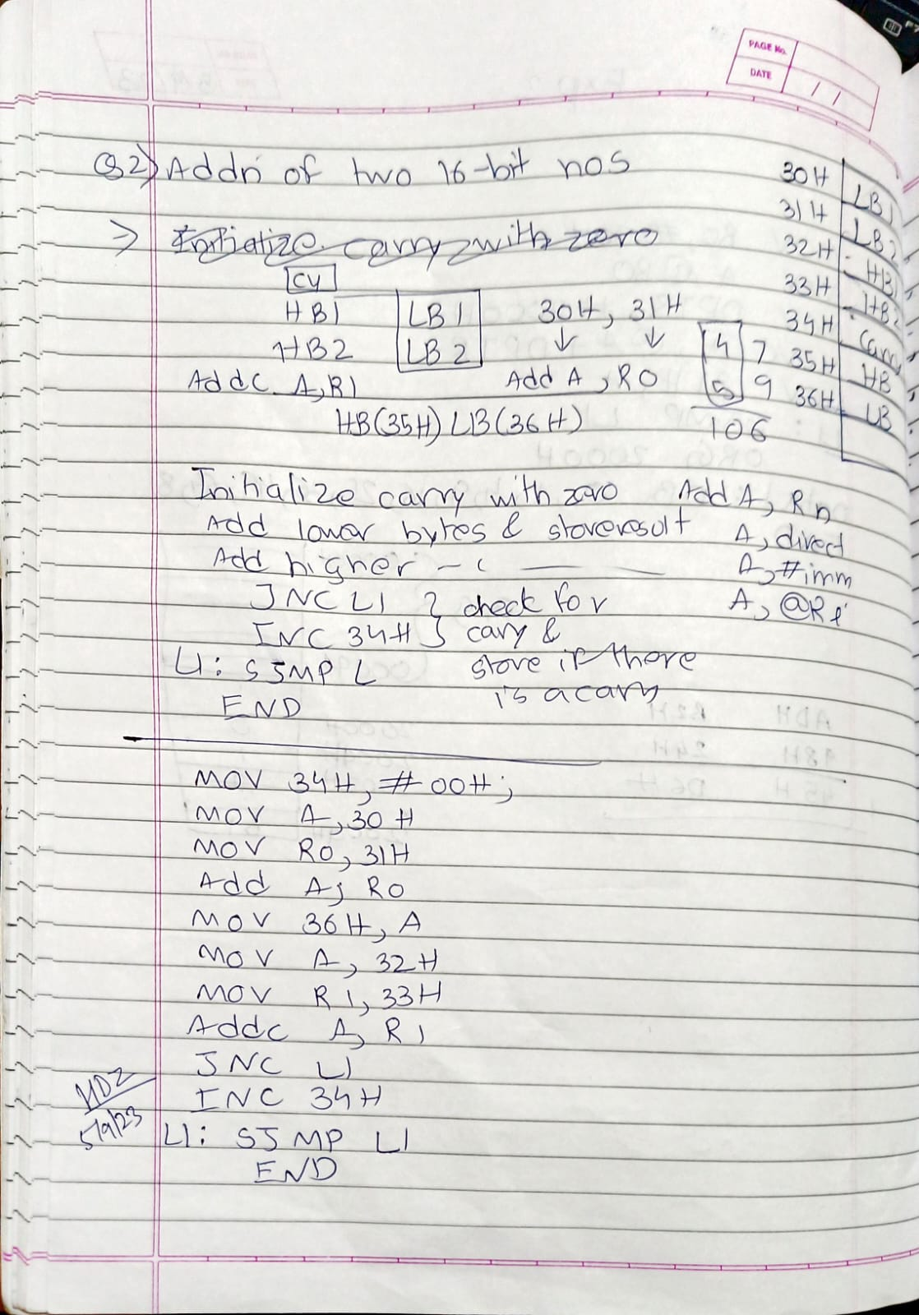

**Practical-3**

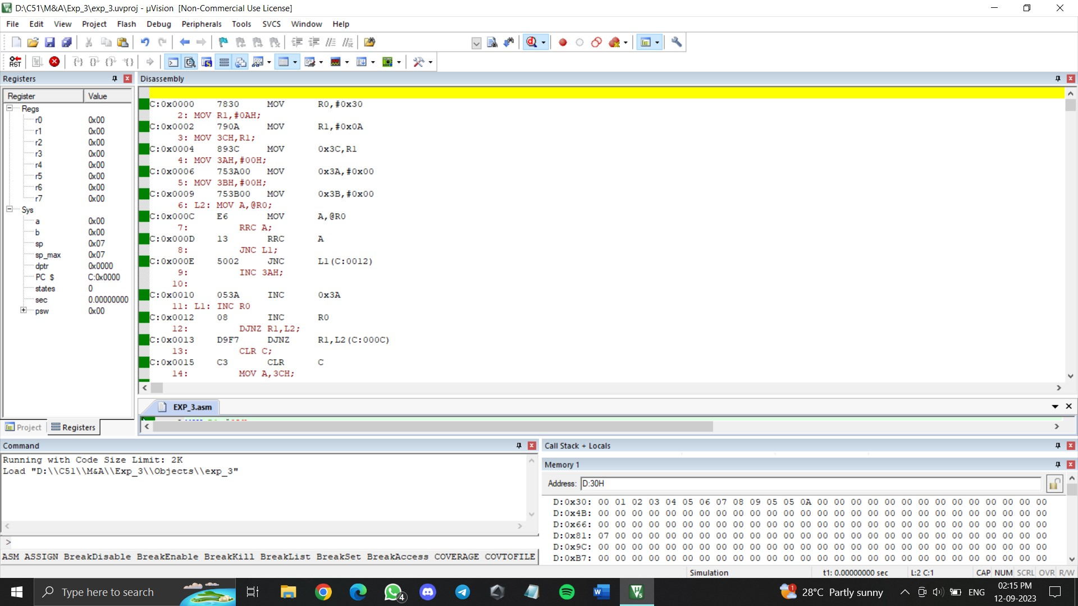



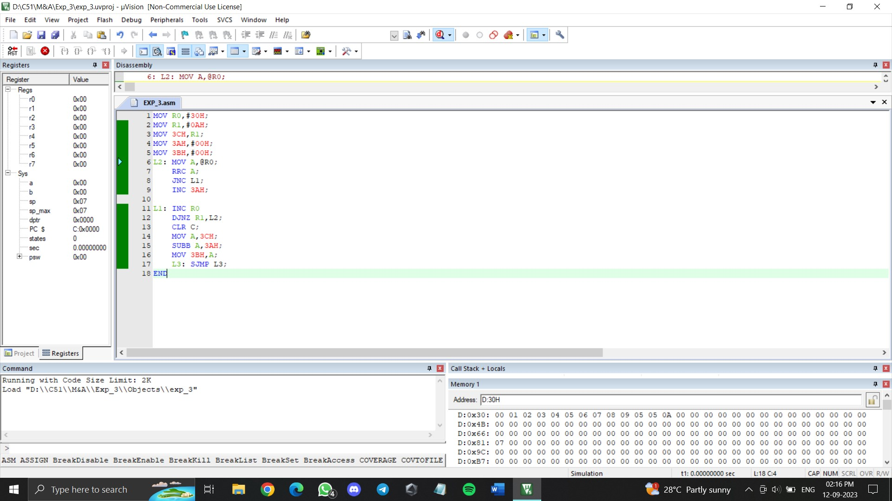

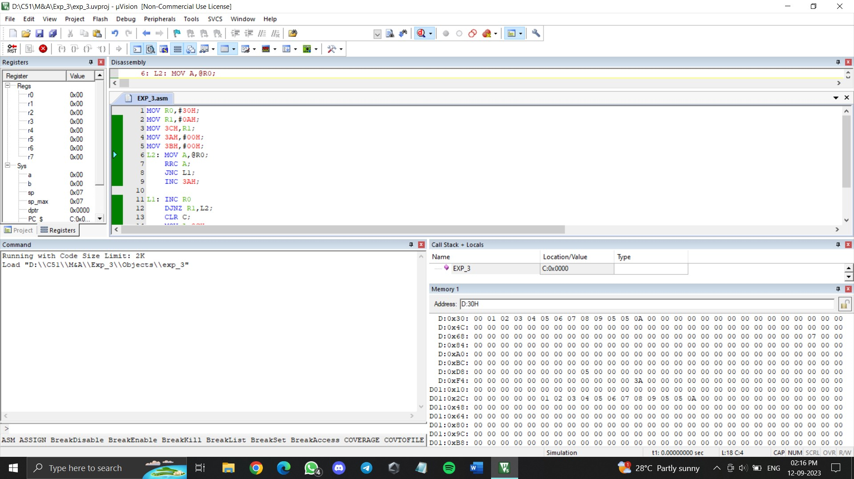

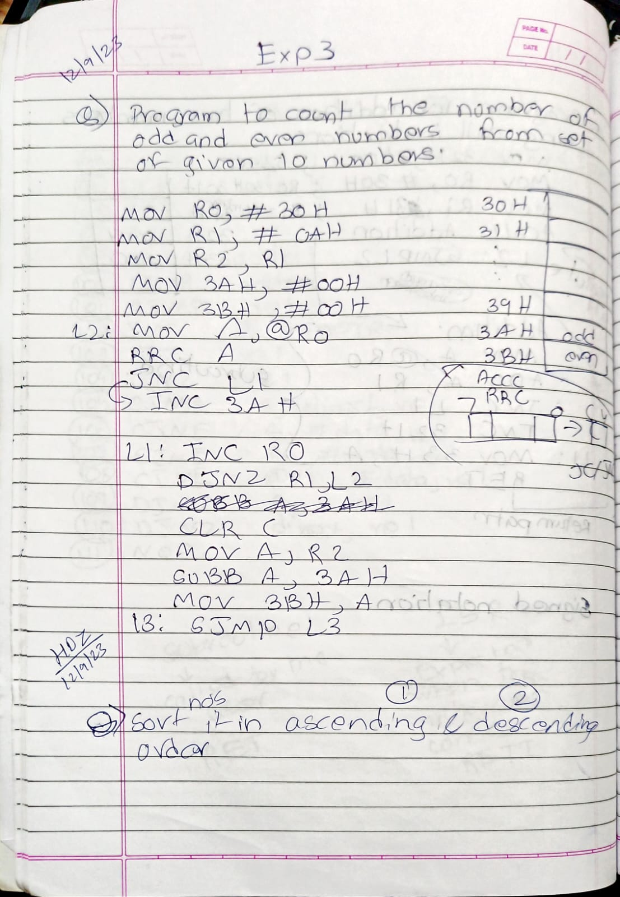

**Post Lab Questions:**

